# 

Academy Membership World Café Event

15th July 2021

# Introduction

The World Café Event was planned as an opportunity for all the chief nurses, or equivalent, members of our Florence Nightingale Foundation Academy to come together, for the first time, face to face, to celebrate the achievements both within their organisations and to each other. This was to be the first major event to be held at the Foundation’s new offices at The Royal College of Obstetricians and Gynaecologists. The event had been planned back in April 2021 and had to be carefully coordinated bearing in mind the changing levels of Covid-19 restrictions and guidelines.

Although it was planned as a completely face to face event, last minute restrictions in the UK meant that some of our Guest speakers, namely Dame Yvonne Moores and Jacqui Reilly, had to do their speeches via Zoom, and projected in the main hall. Attendee numbers were also subsequently affected, not just by the pandemic but to people’s personal situations nearer to the event. As a result, about half of the 85 invited guests attended in person. For those that did attend, 16 have since responded via our response reports, and on average rated the event, 9.3 out of 10.

# Event Objectives

* Celebrate the FNF membership growing from strength to strength. In the last six months membership has grown by over two-thirds from 30 members in December 2020 to 50 by July 2021.

* Stimulate further debate and discussion to address the challenges facing health care to increase the relevance and contribution of our member nurses and midwifes.
* Spread the evidence, best practice and learning generated by members to increase visibility and encourage further membership through the newly introduced Individual, ICS, and the forthcoming international memberships.
* Reiterate the member benefits and to seek where improvements could still be made.

# Schedule

The event schedule was a combination of addresses and keynote speeches by both staff and special guest attendees, who, due to the current Covid-19 restrictions, attended both virtually and in person.

The World Café style element table discussion gave all the participants in the room, an opportunity to share their valuable thoughts and opinions on the future direction of the Membership discussing topics on inclusivity, education, scholarships, events, and growth globally.

The keynote speeches were recorded and are available at these links to view.

Introduction by Professor Gemma Stacy & speeches by Professor Greta Westwood & Dame Yvonne Moores:

[**https://www.youtube.com/watch?v=PL1HOr3rLao**](https://www.youtube.com/watch?v=PL1HOr3rLao)

Update On the FNF Academy Membership by Jacqui Reilly

[**https://www.youtube.com/watch?v=I7QeJOf6JIA**](https://www.youtube.com/watch?v=I7QeJOf6JIA)

Keynote Speaker: Wendy Irwin

**https://www.youtube.com/watch?v=2Y3pCXiHTno**

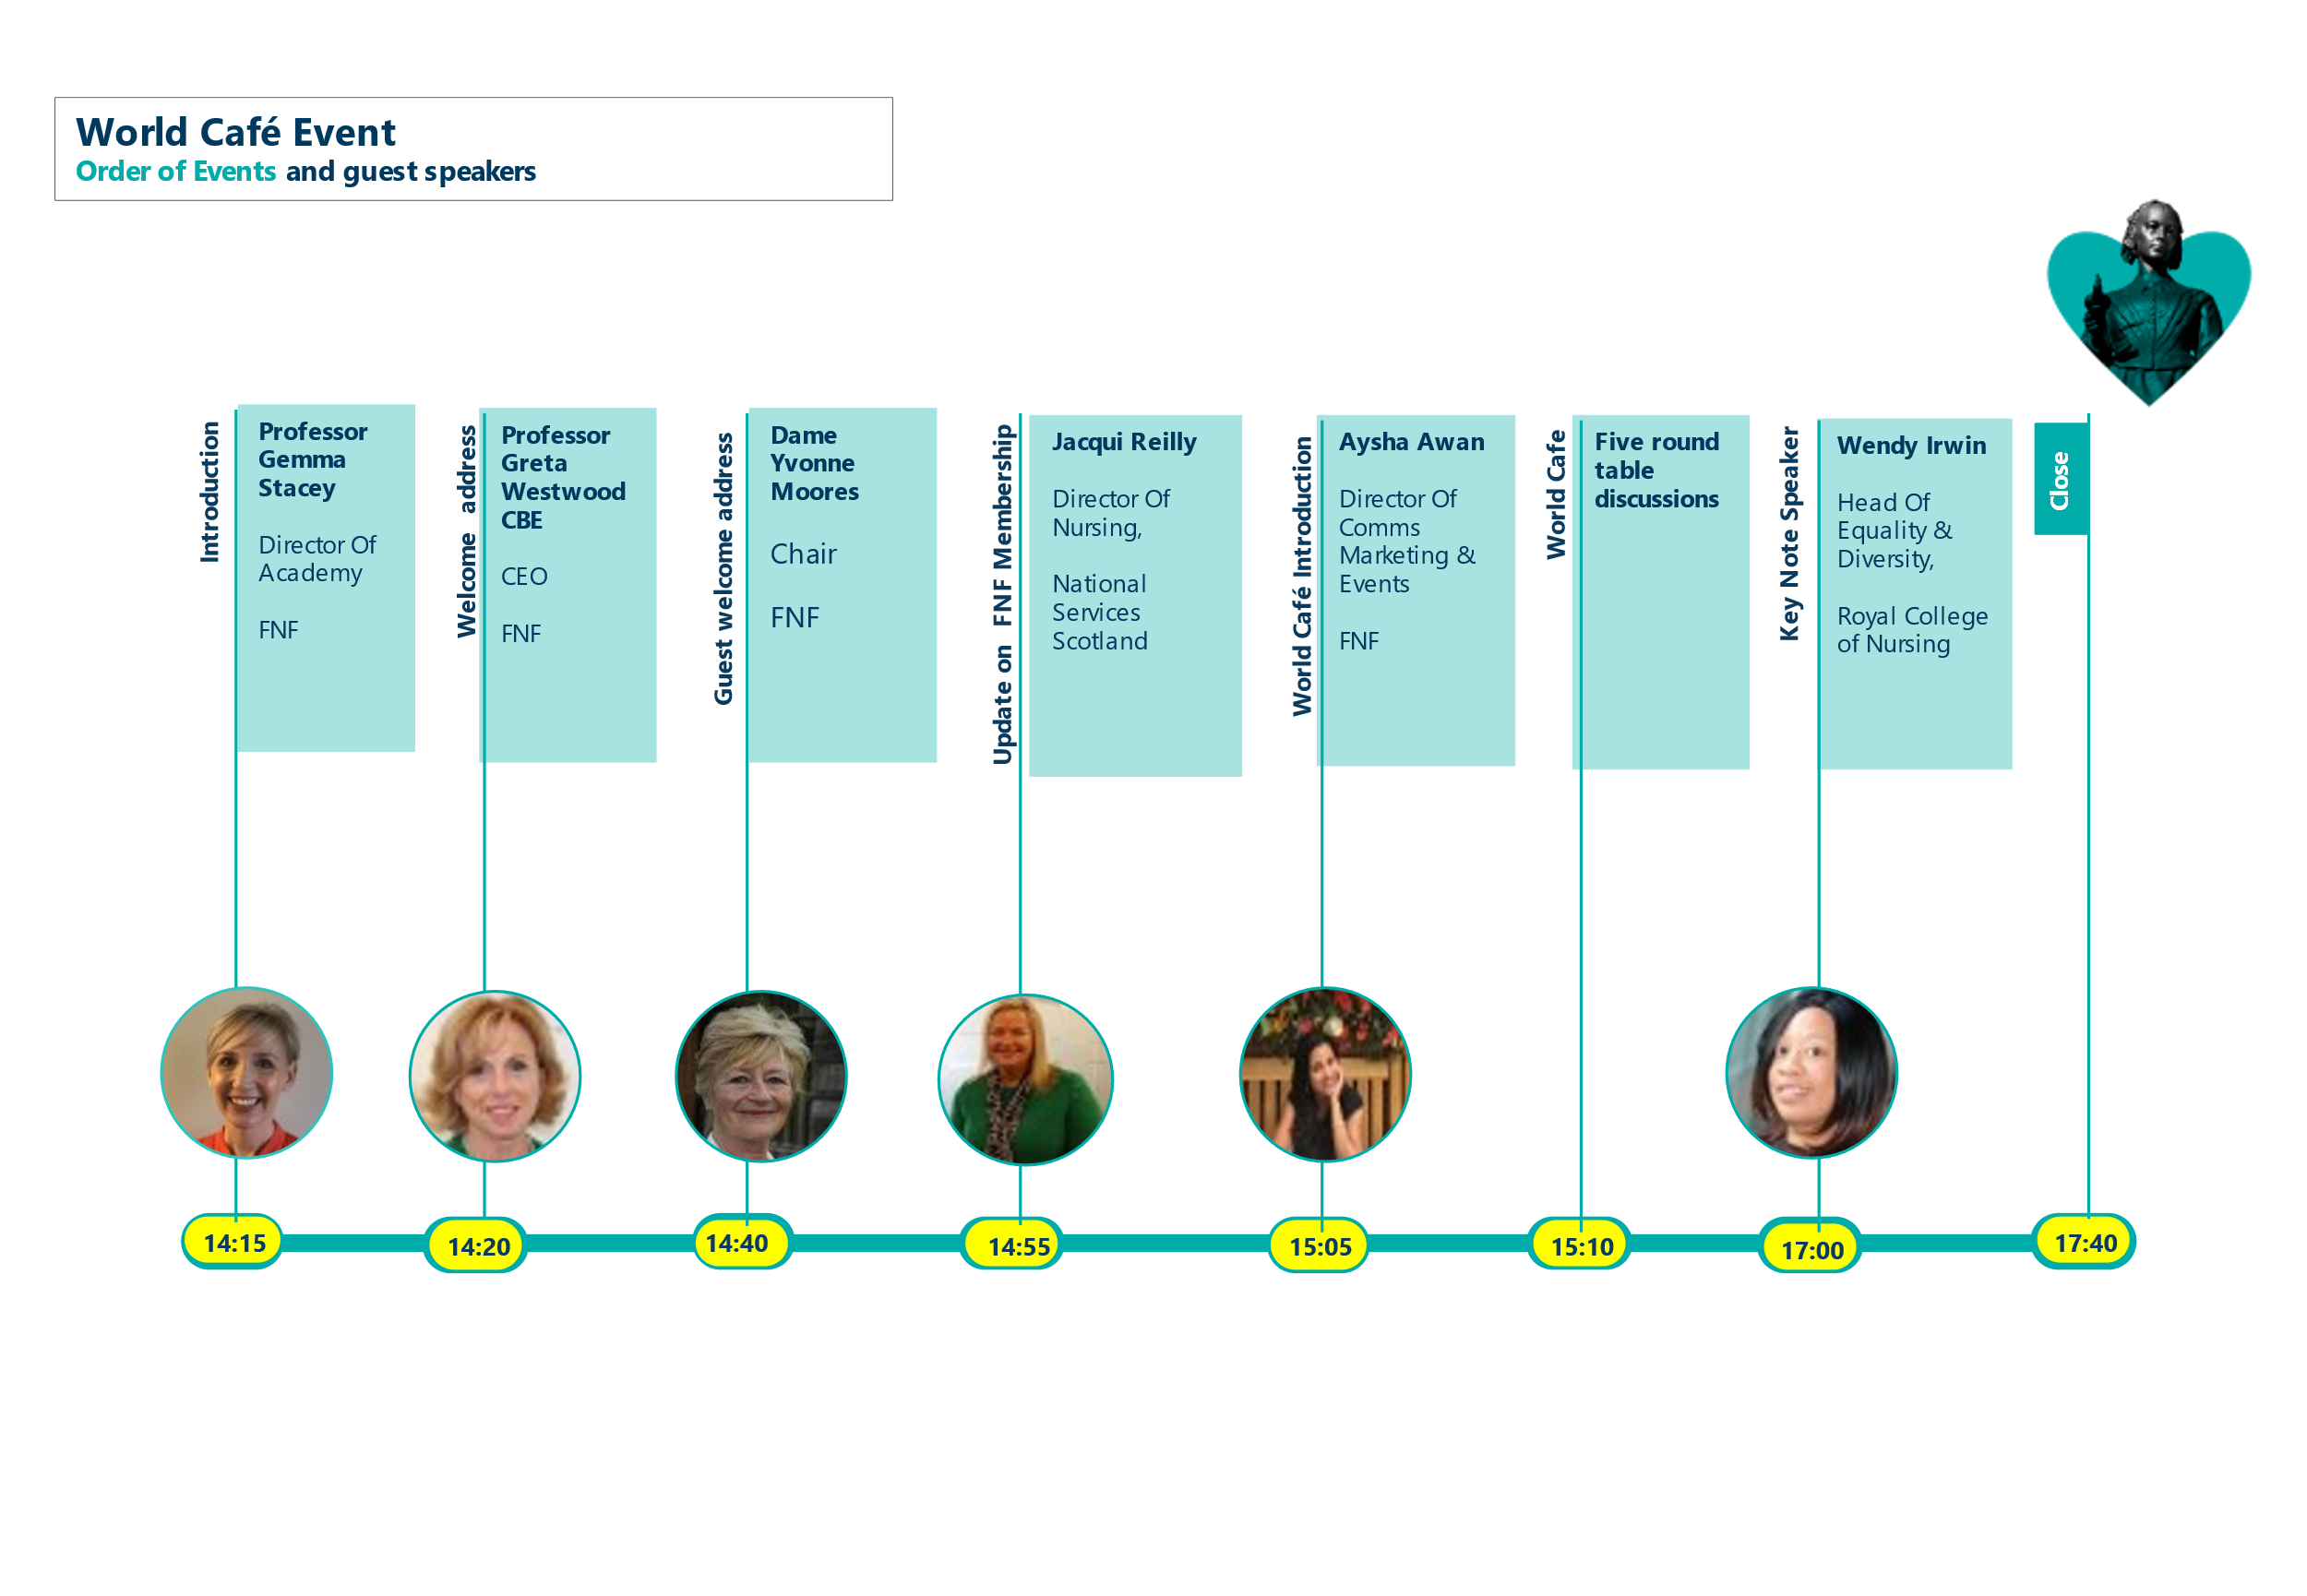

# World Café Table Facilitators

| **Name** | | **Position** | **Table Discussion** |
| --- | --- | --- | --- |
|  | **Sheila Lloyd** | Director Of Nursing  Florence Nightingale Foundation | Diverse and Inclusive Leadership |
|  | **Jess Sainsbury** | Research and Policy Assistant - Student Councils Project Lead  Florence Nightingale Foundation | Clinical Supervision |
|  | **Professor Gemma Stacey** | Director Of Academy  Florence Nightingale Foundation | Membership Education Programme |
|  | **Professor Greta Westwood CBE** | CEO  Florence Nightingale Foundation | Forward Planning |
|  | **Adam Rabinowitz** | Alumni and Membership Manager  Florence Nightingale Foundation | Membership benefits and engagement |

# World Café’ - Table Discussion Themes

Diverse and Inclusive Leadership- Sheila Lloyd

* Authentic leadership is central to this agenda. Bringing whole self to your leadership to be ‘inclusive’.
* There is a disconnect between board to the floor. The policies are making a commitment to addressing the issue but the experiences of nurses and midwifes and other healthcare professionals in the organisation indicate frequent experiences of micro aggression and blocks to career progress/ development opportunities.
* The FNF can help by enabling organisations to create safe spaces, where people can raise their concerns and develop self-awareness and emotional intelligence required to enhance the cultural sensitivity of the workforce.

**Next Steps**

Our key performance indicators collate the diversity of our scholars and delegates to ensure a fair selection process for all our scholarship and leadership programmes. Sheila Lloyd will now lead on this agenda to ensure practices are embedded.

Clinical Supervision- Jess Sainsbury

* Chief nurses do not always understand what is meant by the term and are not role modelling it within their organisation themselves. FNF can support senior leadership to understand the concept and think about embedding in their organisations.
* Protecting time for our nurses to access clinical supervision is the biggest barrier. FNF can support by influencing regulars and workforce planning to ensure this is mandated.
* FNF should work with the NMC to take this forward as you believe it requires regulatory influence. The RCN also have role in this.

**Next Steps**

Our Clinical Supervision Expert Working Group led by Jess Sainsbury is working closely on the national agenda to address access to clinical supervision for all nurses and midwives. This includes influencing chief nurses nationally.

Leadership and Education Programmes - Gemma Stacey

* Supporting nurses to be influential within the development and establishment of the Integrated Care Systems.
* Share varied career journeys of members to inspire early career nurses and demonstrate the range of pathways.
* Create and establish a mentorship network which members will contribute to as both mentors and mentees.

**Next Steps**

Lucy Brown, Our Deputy Clinical Chair and Adam Rabinowitz are working on the expansion of the membership offering across ICS, Higher Educational Institutions (HEI’s) and globally. Additionally, we are sharing case studies to share our diverse and varied scholar career journeys. We have also commenced plans to expand our mentorship offering to all scholars and delegates utilising our established alumni network.

Forward Planning - Greta Westwood

* Increase the visibility and accessibility of FNF to nurses and midwives working in all settings. This will require FNF to challenge the perception of the organisation as elitist.
* Expand the collective voice of nursing by developing into a global network.
* Explore the potential of FNF becoming an accrediting body.

**Next Steps**

We are excited to share we are working on a global strategy to expand our collective voice and increase our visibility and accessibility. Our Global Committee meets for its inaugural meeting in October 2021.

Membership Benefits and Engagement – Adam Rabinowitz

* The Academy membership benefits were reiterated to all members attending, to make sure there was an understanding of all that we offer.
* Strategies for disseminating newsletters and membership benefits were identified to ensure the information reaches all nurses and midwives in the organisation. This includes printable posters, event flyers and utilisation of social media

**Next Steps**

We have changed our newsletter format and providing additional advertising collateral to make sharing resources easier. We are also working on a dedicated membership and alumni website with easy access to all resources.

**PARTICIPATION**

## Of the 85 people invited, 53 people confirmed they would attend.

## 

**Social Media Engagement**

* **LinkedIn** –6 updates were posted on FNF’s LinkedIn. They received 4968 views for the pre-event post and 1626 views for the post event reflective account. Main contacts include healthcare and commercial business leaders.
* **Twitter** - 7 tweets were shared about World Café on July 15th from FNF’s account. Twitter impressions were 42,900 on July 15th and grew to 77,900 as the week went on. This was peak reach for the FNF Twitter account for the whole month of July.

**Post Event Evaluation**

# A post event evaluation form was disseminated, and 13 completed forms were received.

* Question: How would you rate the event out of 10?

# Range 7 - 10

# Average 9.2

* Question: Did the event meet your expectation?

# Range 8 - 10

# Average 9.3

* Question: Would you recommend the event to colleagues?

# Range 8 - 10

# Average 9.4

* Question: What did you find most useful from the event?

**Networking**

**Understanding and informing the future vision/ strategy/ ambition of the FNF**

**Exceptional & inspiring guest speakers**

* Question: How can we improve future events?

**Extend networking opportunities when social distancing allows**

**Examples from members who have benefited from the network**

**Input into topics for discussion**

* Question: What membership benefits do you value most and why?

**Webinars**

**Leadership development through scholarships**

**Future prospects of global networking**

**Positive feedback from staff who have attended development sessions**

* Question: How can we further develop the membership offering?

**Continue free access to webinars**

**Continue regular communication**

**Expand membership reach**

**Accreditation of members’ internal leadership programmes**

**Private members area on website**

**Global networking**

* Question: Would you be interested in joining our mentorship network?’

**10 positive responses**

**Highlights**

* A successful socially distanced networking event specially for our membership of the Florence Nightingale Academy.
* Over half of our members made the journey to our new offices at The Royal College of Obstetricians and Gynaecologists.
* Each of the world café discussion tables generated significant intelligence to inform the strategy of FNF and take forward our policy priorities.
* Evaluation of the event was extremely positive and demonstrated the value of the networking opportunity
* Keynote speakers, including Wendy Irwin, Dame Yvonne Moore and Professor Greta Westwood CBE were identified as inspiring.
* Awareness of the Academy membership benefits were reinforced and as a result more nurses and midwifes have access to these.
* There were over 77,900 Twitter impressions and almost 5,000 impressions via LinkedIn because of our social media communications.

# In summary the event enabled an exchange of knowledge FNF and members and opportunity for networking amongst senior nurses spanning the full range of health and social care provision. The potential influence of the membership network was clear and the motivation and commitment to collectively inform policy makers was established. This momentum will continue to be mobilised through our webinars, leadership programmes, policy priority areas and subject expert groups.

# 

Support us to continue Florence’s legacy.

**T:** 020 7730 3030 **E:** [admin@florence-nightingale-foundation.org.uk](mailto:admin@florence-nightingale-foundation.org.uk) **W:** florence-nightingale-foundation.org.uk @FNightingaleF FlorenceNightingaleFoundation  @florencenightingalefoundation

10-18 Union St, London SE1 1SZ